Array Operations in BASH

1) Declare an Array names of length 7 and find

a. The total number of elements

b. Print all the elements

c. Print the 5th element

arrays.sh

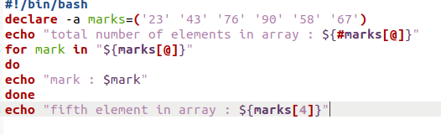

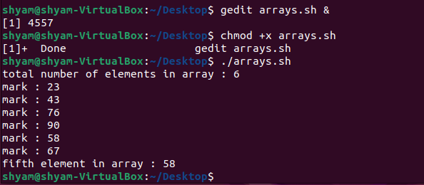Terminal